How to add the title to a bar graph and make the value appear on the top of each bar on an Alma Analytics graph | 
Yoel Kortick
Senior Librarian

Question:
I have made a graph in my Alma Analytics report but I only see the actual amount in each bar if I roll my mouse over the bar. How can I put the actual value above each bar? I know it is possible because I have seen other libraries do it. I also want to change title which is now giving by default the name of field.

I create my graph by choosing the default bar graph

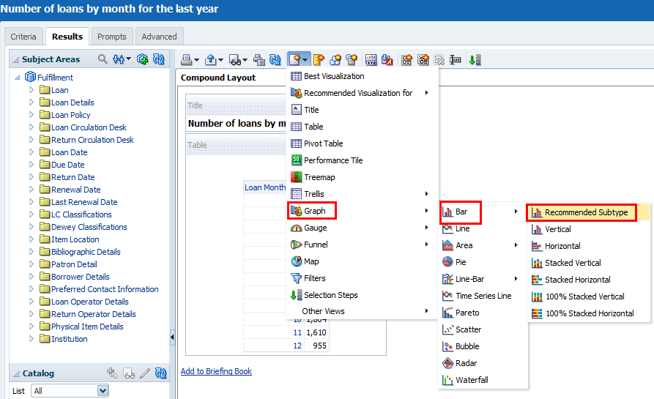

But I do not see the values above each bar

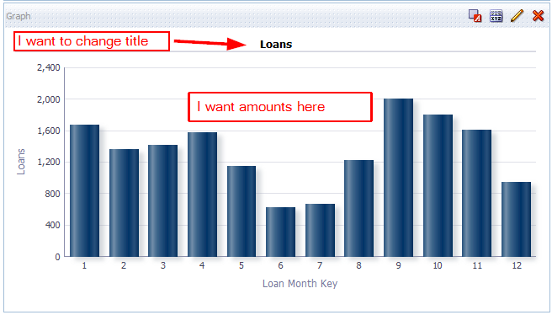

Answer:

ONE
When the graph is open in the “results” tab click the “View Properties”

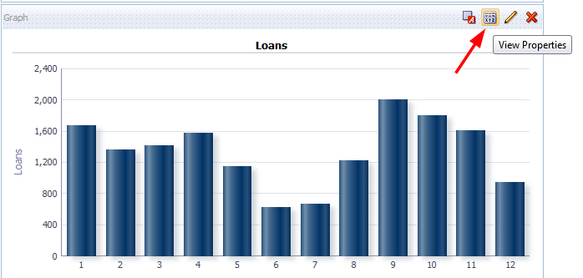

TWO
In the “Titles and Labels” tab uncheck “Use measure name as graph title”

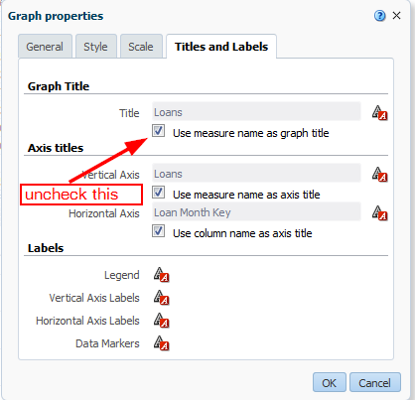

Put your desired title

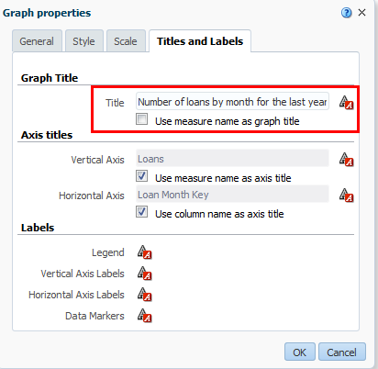

THREE
In the “Titles and Labels” tab click “Data Markers”

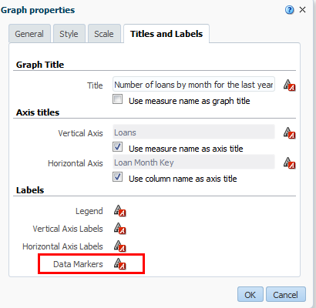

FOUR
In the “Display Options” tab choose “Always” instead of “Default (On rollover)”

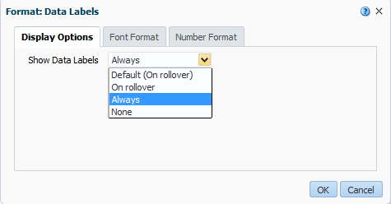

FIVE
Click “OK” for both changes, and now see desired title and results with values

